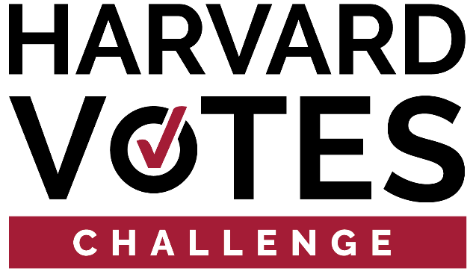

CENSUS 2020 TOOLKIT

2020 is an important year for our democracy. Though news and conversation are dominated by the presidential election, equally critical civic activities such as the decennial census are underway.

It’s important for all of us to be counted in the census, and be counted in the right place. A complete count of the Harvard community is critical to secure the public funding and services needed to support the thousands of people who call Harvard University their home. In addition, the coronavirus pandemic is shedding light on the vital services we receive from our government, including hospitals and emergency care.

This document will provide an overarching narrative for the Harvard community to use regarding the Census, including key talking points, suggested social media content, and example graphics for use on Twitter and Facebook. It will also offer talking points specific to the ongoing coronavirus pandemic, and how to mitigate key concerns from students and the broader Harvard community about being counted.

KEY TALKING POINTS: WHY TAKE THE CENSUS

- April 1 is Census Day and our chance to take a snapshot of the nation and make sure that every person is counted
- It’s important for all of us to be counted in the census, and be counted in the right place
- A complete count of the Harvard community is critical to secure the public funding and services needed to support the thousands of people who call Harvard University their home
- Starting March 12, the Census Bureau mailed an invitation to participate in the census to every household in the country. If any Harvard community member moved before receiving this census invitation, they can still respond by visiting the Census Bureau’s website
- You can choose between a paper form, a phone call to the Census Bureau, or a quick online survey - just 10 minutes can change the next 10 years for you and your family
- When you get your invitation to participate in the 2020 Census, you can choose to respond by phone in 13 languages, or by TTY by dialing 844-467-2020

KEY TALKING POINTS: HARVARD-SPECIFIC

- All students living in freshman, undergraduate, and graduate housing will be automatically counted and reported to the Census by Harvard
- Harvard community members such as staff and faculty should respond to the census using their home address

KEY TALKING POINTS: COVID-19

- The census is designed for people to respond on their own. That means you can take the 2020 Census right now in the comfort of your own home
- Students who moved out of Harvard housing due to the coronavirus-mandated evacuation should still be counted as living on campus, regardless of where they reside on April 1
- Students who recently moved back home with their parents or into other housing arrangements should not be counted under their new address; instead, they will be counted by the school in accordance with a Harvard administrator’s email dated March 19th

SAMPLE TWITTER POSTS

- As Harvard has responded to the COVID-19 pandemic many things have changed on campus, but how the Harvard community should respond to the census has not. Find out more -> bit.ly/33RTaDh
- Pre-Census Day Tweet: Countdown to #CensusDay: [x] days! This year, make sure #EveryoneCounts by reminding your family, neighbors, friends, and colleagues to fill out the 2020 Census.
- Who counts on #CensusDay? #EveryoneCounts! If you’re living in America, you should be counted in the 2020 Census. Spread the word and make sure all your friends and family get counted.
- #CensusDay is finally here! With funding for schools, roads and hospitals at stake, how are you ensuring that #EveryoneCounts in the 2020 Census?

SOCIAL MEDIA GRAPHICS

